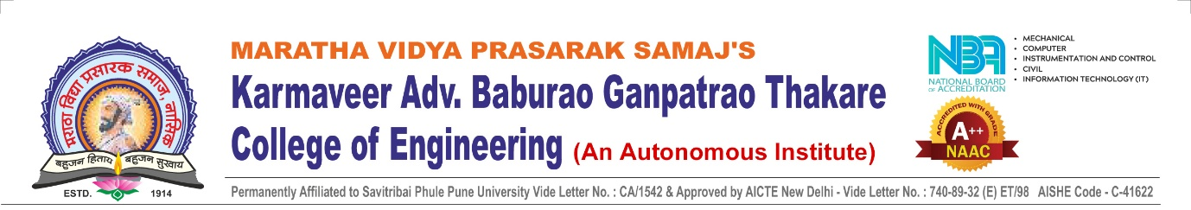

KBT ANVINYATHON
Rule Book
(KBT College of Engineering, Nashik)

1. Introduction
KBT Anvinyathon is a competitive innovation event organized by KBT College of Engineering to encourage students to develop creative, practical, and technology-driven solutions to real-world problems within a limited timeframe.
The hackathon aims to promote innovation, interdisciplinary collaboration, and industry-oriented problem solving among students.

2. Eligibility
- The hackathon is open to Undergraduate and Postgraduate engineering students.
- Participants must be enrolled in a recognized educational institution.
- Students must carry a valid college ID card during the event.
- Each participant may be part of only one team.

3. Team Formation
- Each team must consist of minimum 2 and maximum 5 student members.
- Students must belong to the same college.
- Students from the same department are allowed. However, interdisciplinary teams (members from different departments) are highly encouraged to promote diverse technical expertise and innovative solutions.
- All team members must be registered before the event.
- Team composition cannot be changed after registration closure.
- One member must be designated as the Team Leader.

4. Registration
- All teams must complete registration within the announced deadline.
- Incomplete or late registrations will not be accepted.
- Confirmation of participation will be communicated through official channels.

6. Rules and Guidelines
- All submissions must be the original work of the team.
- Use of open-source libraries, APIs, and frameworks is permitted with proper acknowledgment.
- Plagiarism, cheating, or unfair practices will lead to immediate disqualification.
- Teams must maintain ethical and professional conduct throughout the event.
- Organizers reserve the right to inspect progress during the hackathon.

7. Submission Requirements
- Teams must submit their final solution before the announced deadline.
- Submissions must include:
  - Project Description
  - Source Code / Implementation Details(Git Hub)
  - Demonstrable Prototype or Output
  - Presentation .
- Late submissions will not be accepted.

8. Evaluation Criteria
Projects will be evaluated based on:
- Innovation and Originality
- Technical Complexity and Implementation
- Feasibility and Practical Impact
- User Experience and Design
- Presentation and Demonstration
The decision of the judges shall be final and binding.

9. Code of Conduct
- Participants must maintain professionalism, mutual respect, and discipline.
- Any form of harassment, discrimination, or misconduct may result in disqualification.
- All participants must adhere to academic and ethical integrity.
- Decisions of the organizing committee shall be final.

11. Amendments
The organizing committee reserves the right to modify the rules and regulations at any time. Any changes will be officially communicated to the participants.

